**ECEN4013 Individual Research Report**

**Blake Schlesinger**

1st October 2015

The blocks of personal responsibility from the Team2 functional block diagram consists of “**Blade and Grip Design**” and “**Power**”.

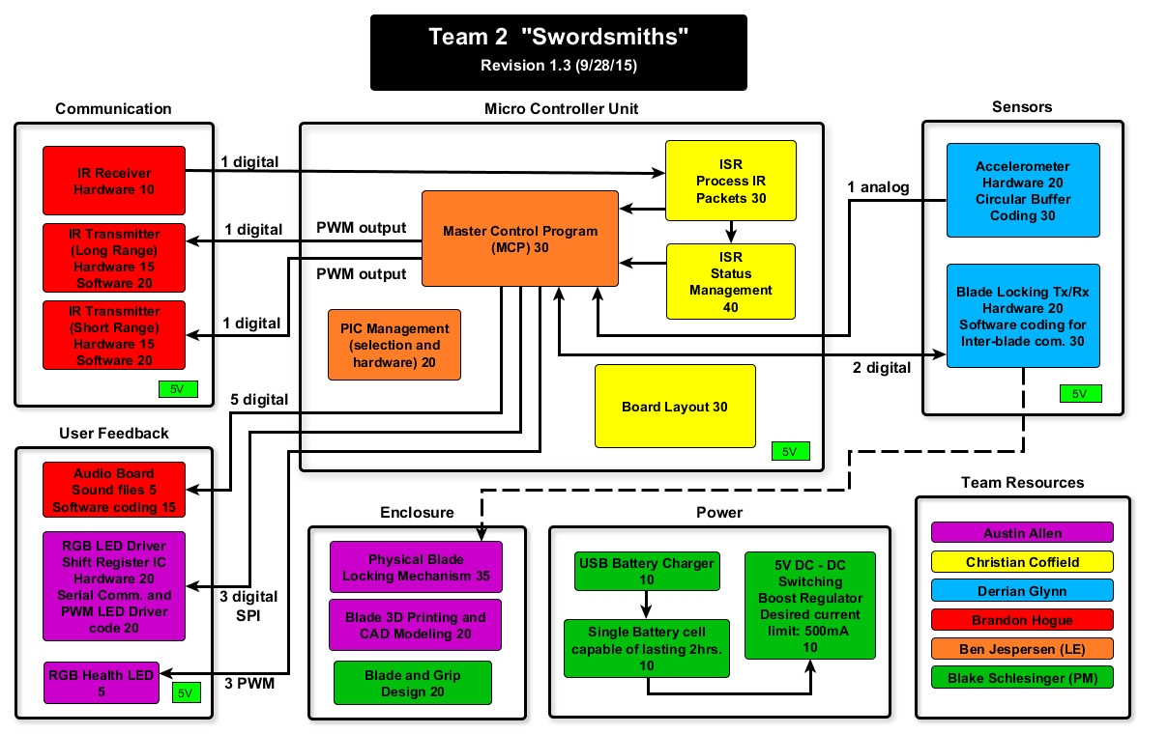

   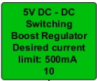

Availability verified for all items listed in report.

**Blade and Grip Design**

BLADE:

1. **Wood –** This material is the first choice for the blade section of the sword due to its malleable properties and ease of use. Rigidity is a top consideration since it will contain electrical components. It is readily available and cheap. Wood also presents a more professional finish to the product when compared to foam.
2. **Foam (polyethylene “the pool-noodle material”) –** As a second choice, foam offers flexibility in terms of physical characteristics and is the reason it is the second option since a rigid material is preferable. Durability is of concern with polyethylene foam since this type of foam does not withstand abrasion well over time. More importantly, the porous nature of foam inhibits ease of affixing components to the blade. Some foam products commercially available offer a hard plastic core but are more expensive.

GRIP:

1. **Fiberglass Hockey Stick –** Given the dimensional constraints in the Omega Blade requirements document, fiberglass is well suited for the grip material due to its strength to weight ratio. Specifically, composite (fiberglass) hockey sticks offer a unique solution to the mechanical aspect of this project since they are hollow on the inside, fit just within the dimensional requirements, and the wall of the sticks is minimal, allowing for space without sacrificing strength.
2. **Wood –** This is a solid second choice since it is easy to work with as previously stated. Having a unified material across both the grip and the blade is a plus but housing space would not be gained as the thickness of the enclosure wall would have to be fairly substantial so that the grip would not split under the stress of a swing.
3. **Plastic –** Like fiberglass, this too would provide strength while allowing for more space and a minimal wall enclosure thickness. It possible to find hollow plastic tubing, however, the options largely exceed the dimensional requirements and are not as well suited for the application in terms of dimensional optimization as the fiberglass hockey stick.
4. **Leather Grip Wraps –** As a side task, some research was done on cheap leather stripping for the sword grips to provide an ergonomic feel, an aesthetic flare, and overall quality to the product.

**Power**

BATTERY:

**Single Cell VS Multi-Cell Batteries –** For this project, a single cell battery will be used for a couple reasons. First, the stringent dimensional constraints of the blades make a single cell a more viable option in terms of availability. Second, a single cell reduces the complexity of the charger circuitry by not requiring components to balance the individual cells. This is critical with multi-cell battery packs.

**Total System Current Requirements –** As stated in the requirement document for the Omega-Blade, each blade must achieve a minimum continuous run time of 2 hours. To accomplish this, the constant current draw of the system must not exceed half the capacity of the battery. Ideally, this is not the case as the battery capacity is less than advertised meaning that it is wise to have an error buffer of reduced capacity.

**Note:** The following is an estimate and it is should be pointed out that actual testing during the prototyping phase may not accurately reflect on the theoretical values for the components used in the project from the various manufacturers.

**Best Case Total Current Consumption:**

1. IR Emitters (long range): 88mA x3 (per IR emitter)
2. IR Receivers: 2mA (total for 4 IR receivers per blade)
3. Sound breakout board: 155mA
4. RGB health LED: 60mA
5. RGB swing indicator LEDs: 60mA x2 at any given time

Total: 661mA

Assuming that the sword could feasibly be swung every second and knowing that the LEDs and IR emitters pulse for less than half a second, this value can be divided by two to get a total of **330mA**.

**Worst Case Total Current Consumption:**

1) IR Emitters (long range): 200mA x3 (per IR emitter)

2) IR Receivers: 2mA (total for 4 IR receivers per blade)

3) Sound breakout board: 155mA

4) RGB health LED: 60mA

5) RGB swing indicator LEDs: 60mA x2 at any given time

Total: 997mA

Assuming that the sword could feasibly be swung every second and knowing that the LEDs and IR emitters pulse for less than half a second, this value can be divided by two to get a total of **498mA**.

1. **Lithium Polymer (LiPo)** – This is the first choice for the following reasons. Backed by technical data, it is the battery technology with the highest energy density compared with NiMH, Alkaline, NiCad and others. LiPos are also cost competitive with other battery technologies and are quite affordable. This technology is also practical because it allows for many different sizes and shapes not found with other battery technologies.

|  |  |  |  |
| --- | --- | --- | --- |
|  | **Walkera** | **Turnigy** | **Powerizer** |
| **Battery Chemistry** | LiPo | LiPo | NiMH |
| **Capacity** | 1600 | 1200 | 2600 |
| **Nominal Cell Voltage(V)** | 3.7 | 3.7 | 1.2 |
| **Wired Connectors** | Yes | No | No |
| **Price($)** | 8 | 3 | 3 |

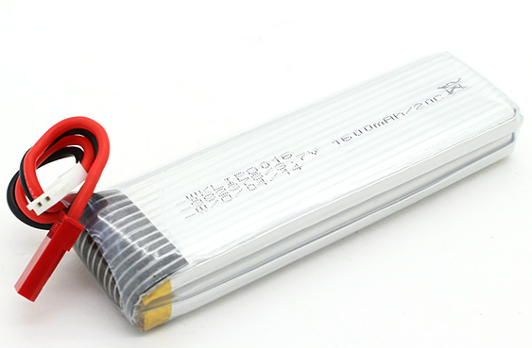

* 1. Walkera 1S 3.7V 1600mAh LiPo
     1. Connector: JST
     2. Dimensions: 78x25x11mm
     3. Max Discharge: 20C
     4. Max Charge: 2C

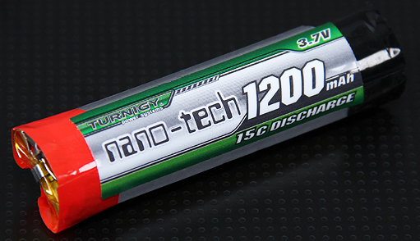

* 1. Turnigy nano-tech 1S 3.7V 1200mAh Lipo (round cell)
     1. Connector: N/A
     2. Dimensions: 58x15mm
     3. Max Discharge: 15C
     4. Max Charge: 5C

1. **Nickel Metal Hydride (NiMH) –** As a second choice, some of these batteries would be a feasible alternative but are impractical given their cylindrical structure. Because they are cylindrical cells and since wires cannot be soldered directly to battery terminals, they require a battery holder which provides a means of wire connections but simply adds space and not capacity. They can withstand more abuse than lithium cells in terms of charging, but this is only beneficial when considering long term use which is not an issue for this project. Would reqire more cells to achieve desired voltage.

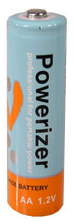

* 1. Powerizer 1.2V 2600mAh NiMH (truth be known, it’s a Panasonic cell underneath the branding)
     1. Connector: N/A
     2. Dimensions: 14.5x50mm
     3. Max Discharge: 2.6A (1C)
     4. Max Charge: 2.6A (1C)

USB CHARGING CIRCUIT:

**Charging Strategy –** The goal is to have a charging circuit with a constant current charging IC to maintain a suitable ‘C’ rate of charge while the voltage rises to reach the charge potential of the battery. To achieve the maximum battery potential for both LiPo and NiMH battery chemistries, there are at least two charge phases desired when looking for a power management IC. The first is a constant current charge phase and the second is a constant voltage charge phase in which the current is regulated to maintain the maximum battery potential.

|  |  |  |  |
| --- | --- | --- | --- |
|  | **Sparkfun LiPo Charger** | **TI bq2000** | **Bq2002/F** |
| **Battery Chemistry** | LiPo | LiPo/NiMh/NiCad | NiMH/NiCad |
| **Constant-current** | Yes | Yes | Yes |
| **Constant-voltage** | Yes | Yes | Yes |
| **UVLO** | Yes | Yes | Yes |
| **Price($)** | 8 | 3 | 2.5 |

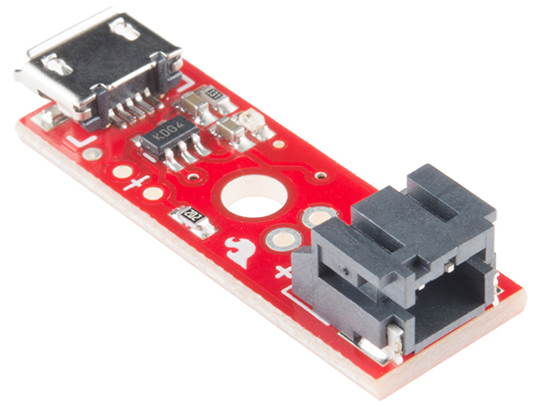

1. **Microchip MCP73831 (Sparkfun COTS) –** Provides a multistage charge cycle involving preconditioning, constant-current, and constant-voltage stages. It is specifically designed for LiPo battery technology and therefore chosen to target the primary battery choice. It is a plug-n-play module with integrated USB and battery connection ports for ease of integration and V&V.

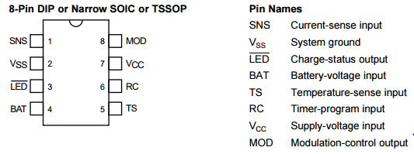

1. **Texas Instruments bq2000 PMIC –** Provides battery chemistry detection using Vmcv check and controls charging via constant-current and constant-voltage stages.

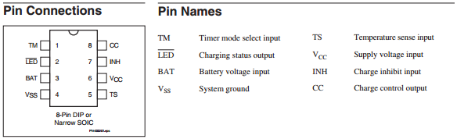

1. **Texas Instruments bq2002/F PMIC –** Provides fast charge capability for NiMH and NiCad technology. Some features include Peak Voltage Detection (PVD) and voltage hold-off timing during fast charge initiation.

**Regulator Strategy –** A Switch Mode Power Supply (SMPS) will be the primary regulator used with the battery to deliver adequate current at 5V across the board. Linear Drop-Out (LDO) regulators will not be used with the only possible exception being for extremely low power peripherals. For example, in the event that an accelerometer requiring a 3.3V supply rail is chosen, an LDO may be used as a secondary voltage reduction stage since the **voltage difference** is low and the **current requirements** for the accelerometer example is in the low micro Amp range (Two factors that have a significant effect on efficiency.). In the end, SMPSs are highly favored for power efficiency.

|  |  |  |
| --- | --- | --- |
|  | **Pololu Boost SMPS** | **LMR62014** |
| **Input Voltage(V)** | 0.5-5.5 | 2.7-14 |
| **Capable of 5V Output** | Yes | Yes |
| **Max Output Current(A)** | 1 | 1.8 |
| **Price($)** | 8 | 2 |

1. **Commercial off the Shelf (COTS) –** Provides the bare minimum needed to meet project requirements and safely charge a single cell lithium battery.

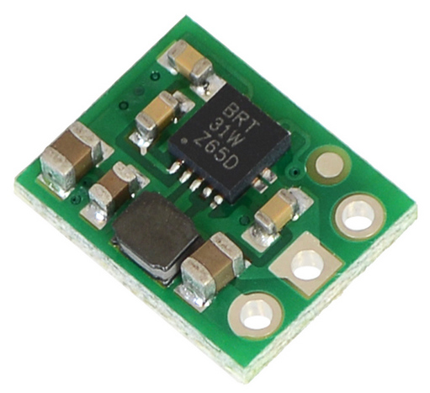

* 1. Pololu 5V Step-Up Voltage Regulator U1V10F5
     1. Dimensions:8.89x11.43x2.54mm
     2. Min Operating Voltage: 0.5V
     3. Max Operating Voltage: 5.5V
     4. Output Voltage: 5V
     5. Max Quiescent current: 1mA

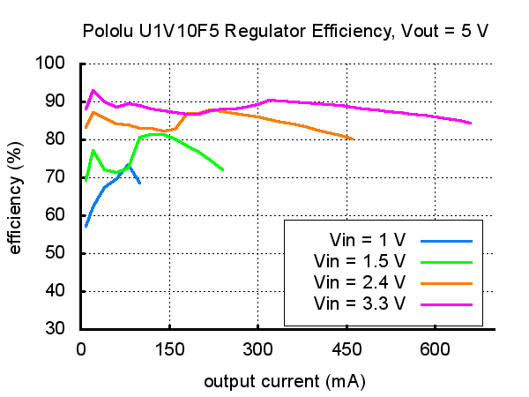

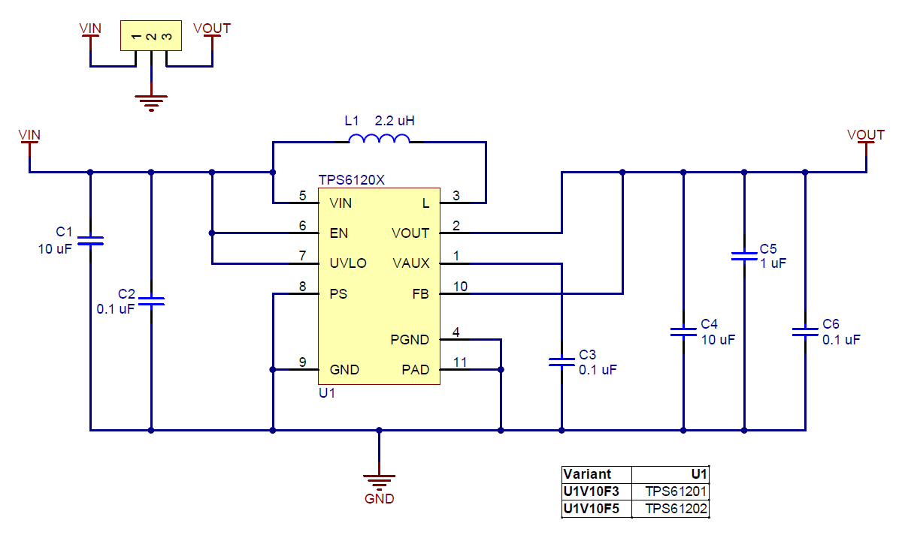

1. **Texas Instruments LMR62014 IC Custom Regulator circuit–** This alternative would be cost effective but is mitigated by the amount of time required to implement the schematic, board layout, milling, and testing. This would also alter the internal layout of the PCB, battery, etc., resulting in unnecessary wiring for inter-blade contacts and does not provide a clean solution.

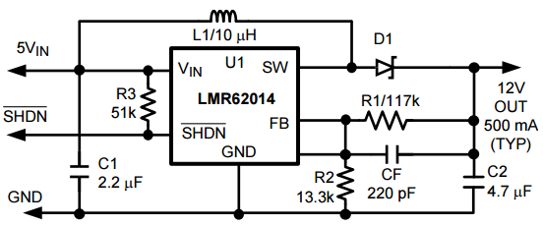

LOW VOLTAGE CUTOFF (LVC) CIRCUIT:

1. **Commercial off the Shelf (COTS) -** Provides the bare minimum needed to meet project requirements and safely charge a single cell lithium battery.

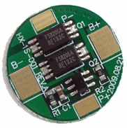

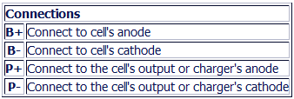

* 1. Tenergy 32002 Protection Circuit Module for 3.7V LiPo
     1. Dimensions: 8.65x0.5mm
     2. Over-charge Protection: 4.3V
     3. Over-discharge Protection: 2.5V
     4. Working current: 3.5A
     5. Over-current protection: 6A
     6. Short circuit protection: yes

1. **555 Timer IC –** This is another viable alternative by utilizing the internal comparators. However, this idea adds more complexity to the prototyping and integration process, and existing LVC COTS are already quite inexpensive.

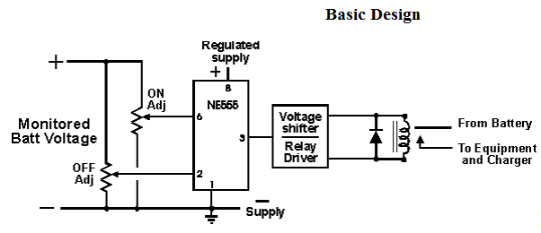

**Switches**

MAIN POWER AND LVC:

**Cherry PRK22J5DBBNN Rocker Switch –** main switch for powering the sword and fits within dimensional constraints.

**E-Switch PS1024A(Red) Momentary Pushbutton Switch –** secondary switch for activating LVC circuit and allowing current to flow.

**Sources**

[1] S. Keeping, 'Understanding the Advantages and Disadvantages of Linear Regulators | DigiKey', *Digikey.com*, 2015. [Online]. Available: http://www.digikey.com/en/articles/techzone/2012/may/understanding-the-advantages-and-disadvantages-of-linear-regulators. [Accessed: 03- Sep- 2015].

[2] M. Day, *Understanding Low Dropout (LDO) Regulators*, 1st ed. p. 7.

[3] Batteryuniversity.com, 'Advantages & Limitations of the Lithium-ion Battery - Battery University', 2015. [Online]. Available: http://batteryuniversity.com/learn/article/is_lithium_ion_the_ideal_battery. [Accessed: 09- Sep- 2015].

[4] Dalhousie University, *Lithium chemical technology and life cycle testing*. 2015.

[5] *Switch-mode Power Supply Reference Manual*, 1st ed. 2015, p. 73.

[6] HobbyKing Store, 'Walkera 3.7V 1600mAh LiPoly Replacement Battery for QR Y100', 2015. [Online]. Available: http://hobbyking.com/hobbyking/store/__57282__Walkera_3_7V_1600mAh_LiPoly_Replacement_Battery_for_QR_Y100.html. [Accessed: 01- Oct- 2015].

[7] HobbyKing Store, 'Turnigy nano-tech 1200mah 1S 15C Round Cell', 2015. [Online]. Available: http://www.hobbyking.com/hobbyking/store/uh_viewItem.asp?idProduct=23320. [Accessed: 01- Oct- 2015].

[8] BatterySpace.com/AA Portable Power Corp. Tel: 510-525-2328, 'NiMH Rechargeable Cell: AA Size, 1.2V 2600mAh -Button Top (1Pc)', 2015. [Online]. Available: http://www.batteryspace.com/nimhrechargeablecellaasize12v2600mah-buttontop1pc.aspx. [Accessed: 01- Oct- 2015].

[9] Pololu.com, 'Pololu 5V Step-Up Voltage Regulator U1V10F5', 2015. [Online]. Available: https://www.pololu.com/product/2564/specs#note3. [Accessed: 01- Oct- 2015].

[10]T. cut-off, 'Tenergy 32002 Protection Circuit Module (PCB) Round for 3.7V Li-Polymer Battery 3.5A Working (6A cut-off)', *BatteryJunction.con*, 2015. [Online]. Available: http://www.batteryjunction.com/tenergy-pcb-3v7-rnd-32002.html. [Accessed: 01- Oct- 2015].

[11]*Miniature Single-Cell, Fully Integrated Li-Ion, Li-Polymer Charge Management Controllers*, 1st ed. Microchip, 2015, pp. 1-28.

[12]*Defense Aquisition Guidebook*, 1st ed. DoD, 2015, pp. 4.3.18.4. Commercial-Off-the-Shelf.

[13]R. Erickson, *DC - DC Power Converters*, 1st ed. Boulder, CO: Department of Electrical and Computer Engineering, 2015.